Appendix -3: Facility Numbers
# | Program Title | Submitting Hospital | Facility Number
2 | a) Sarcoma (Chemotherapy)  b) Sarcoma (Pathology)  c) Sarcoma (Prosthesis) | Royal Victoria Regional Health Center | 606
 |  | Kingston Health Sciences Centre (KHSC) | 978
 |  | Grand River Health Corporation | 930
 |  | Windsor Regional Center | 933
 |  | Thunder Bay Regional Health Sciences Centre | 935
 |  | London Health Sciences | 936
 |  | Hamilton Health Sciences Corporation | 942
 |  | University Health Network | 947
 |  | Sunnybrook Health Sciences Centre | 953
 |  | The Ottawa Hospital | 958
 |  | Health Sciences North | 959
 |  | Sinai Health System | 976

Appendix-11: Valid 2-digits Postal Codes
(Source: Cancer Care Ontario's Data Book - 2012-2013, Appendix B - Province and State codes, at link https://www.cancercare.on.ca/ext/databook/db1213/databook.htm).

The table below provides list of valid 2 digit postal codes for province and State codes.
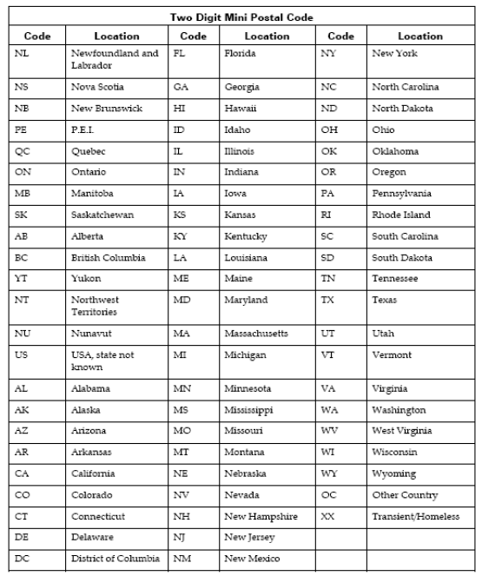

Appendix-20: Morphology Codes
This is a complete listing of valid Morphology codes and includes the new Haematopoietic codes effective January 2010.
Citation for new classification:
WHO Classification of Tumours of Haematopoietic and Lymphoid Tissues, 4th ed., edited by S. H. Swerdlow, et al., International Agency for Research on Cancer, Lyon, 2008. ISBN 978-92-832-2431-0
(For details, please refer Cancer Care Ontario's Data Book - 2012-2013, Appendix 1.36 - Morphology Codes, at link https://www.cancercare.on.ca/ext/databook/db1213/databook.htm)

Appendix-21: ICDO-3 Topography with Laterality
This is a table of topography codes where laterality is applied as stipulated in the FORDS manual.
(For details, please refer Cancer Care Ontario's Data Book - 2012-2013, Appendix 1.3 ICDO-3 TOPOGRAPHY with Laterality, at link https://www.cancercare.on.ca/ext/databook/db1213/databook.htm)

